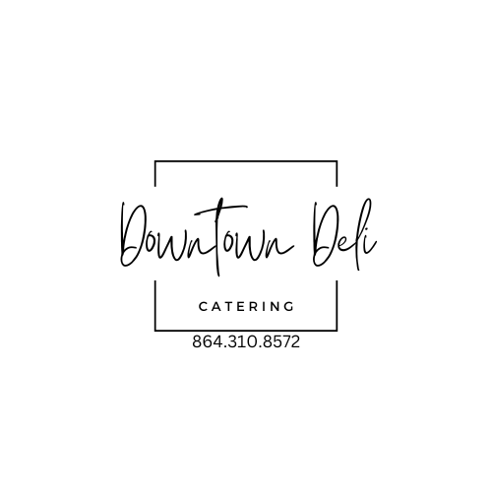
BOX LUNCH OPTIONS
*please note that this is not an A La Carte menu. For groups of 20+ we suggest selecting or giving participants 3-4 menu options. We’re happy to discuss & give suggestions!

SANDWICHES

SIGNATURE CHICKEN SALAD: (on croissant with lettuce & tomato)
ELIZABETH’S PIMENTO CHEESE: (on croissant with lettuce & tomato)
CARNEGIE: (TURKEY OR HAM, PIMENTO CHEESE & BACON)
TURKEY AVOCADO BLT WRAP: (TURKEY, AVO, BACON LETTUCE & TOMATO WITH HERBED MAYO)
CALI CLUB: (TURKEY, HAM, SMASHED AVOCADO, CHEDDAR, BACON, LETTUCE & TOMATO WITH HERBED MAYO)
GROCERY VEGGIE WRAP: (HUMMUS, SPINACH, CUCUMBER, CARROTS, AVOCADO & RED ONIONS) {VEGAN}
SOUTHWEST VEGGIE WRAP: (HUMMUS, ROASTED CORN, AVOCADO, BLACK BEANS, TOMATO, & LETTUCE) {Vegan}
CHICKEN BACON RANCH WRAP: (GRILLED CHICKEN, BACON, RANCH, LETTUCE & TOMATO)
GREEK CHICKEN WRAP: (GREEK MARINATED CHICKEN, SHREDDED ROMAINE, FETA, TOMATOES, GREEK MAYO)
THE BILTMORE: (TURKEY, BRIE, PICKLED ONIONS, ROMAINE, CRANBERRY MUSTARD)
CHICKEN SALAD AVOCADO BLT:( SIGNATURE CHICKEN SALAD, AVOCADO, BACON, LETTUCE & TOMATO, CROISSANT)
SOUTHWESTERN TURKEY WRAP:(OVEN ROASTED TURKEY, AVOCADO, TOMATOES, LETTUCE, BLACK BEANS & CHEDDAR)
TWO BOURROUGHS: (HAM, PICKLES, ROASTED RED PEPPERS, PEPPER JACK & HONEY MUSTARD AIOLI)
CAPRESE WRAP: (TOMATOES, SPINACH, MOZZARELLA, & BASIL PESTO AIOLI WITH A BALSAMIC DRIZZLE)
HAIL CAESAR WRAP: (GRILLED CHICKEN, ROMAINE, PARMESAN CHEESE, TOMATOES & HERBED CAESAR DRESSING)
HAPPY HAM: (HAM, BACON, MIXED GREENS, HAVARTI & CRANBERRY MUSTARD ON CIABATTA)
ALABAMA BROWN COW: (ROAST BEEF, RED ONIONS, PROVOLONE CHEESE, LETTUCE, TOMATO, HORSERADISH AIOLI)
ITALIAN HERO: (HAM, TURKEY, SALAMI, PROVOLONE, SHREDDED LETTUCE & TOMATO WITH HERBED MAYO)

*All Boxed lunches include chips
COOKIE
CUTLERY
12.99 PER PERSON
ADD AN EXTRA SIDE 2.99/UPGRADE SIDE 1.99
GOURMET BROWNIES ADD 1.29
TEA, ICE, CUPS ADD 1.79 PER PERSON
GLUTEN FREE (add 2.50 per person, INCLUDES GF DESSERT & SIDE)

JUST THE BASICS
*ON YOUR CHOICE OF CROISSANT, WRAP OR WHITE

TURKEY & YOUR CHOICE OF CHEESE: (WITH LETTUCE, TOMATO, MAYO & MUSTARD ON SIDE)
HAM & YOUR CHOICE OF CHEESE: (WITH LETTUCE, TOMATO, MAYO & MUSTARD ON SIDE)
CLUB: (TURKEY & HAM WITH BACON, LETTUCE & TOMATO, MAYO & MUSTARD ON SIDE)
ROAST BEEF & YOUR CHOICE OF CHEESE: (WITH LETTUCE & TOMATO, MAYO & MUSTARD ON SIDE) + 1.25
SANDWICHES COME WITH CHIPS, COOKIE & CUTLERY
11.99 PER PERSON

BOX SALADS
$13.99

COBB
(Mixed Greens, Balsamic Chicken, Tomato, Egg, Bacon, Feta, Avocado)

GRILLED CHICKEN BLT CAESAR
(Crispy Romaine, Marinated Grilled Chicken, Bacon, Tomato, Parmesan & Herbed Caesar Dressing)

SOUTHWEST CHICKEN SALAD
(Mixed Greens, Jerk Chicken, Tomatoes, Roasted Corn, Black Beans, Cheddar Cheese,
Avocado)

SIGNATURE CHICKEN SALAD
(Chicken Salad on Mixed Greens with Seasonal Fruit or Cucumbers & Tomatoes)

HOUSE SALAD($3.99)
(Mixed Greens, Tomatoes, Cucumbers & Feta)

DRESSING OPTIONS: RANCH, HOUSE(RED WINE VINAIGRETTE), CILANTRO LIME, ITALIAN, CAESAR, BALSAMIC

*please note that this is not an A La Carte menu. For groups of 20+ we suggest selecting or giving participants 3-4 menu options. We’re happy to discuss & give suggestions!

